The Work of the People (The Liturgy)
King of Glory Lutheran Church
Newbury Park, CA
Sunday, February 28, 2021 2nd Sunday of Lent

NOTE: The People will read the bold print
Assisting Minister: Welcome to Worship at King of Glory
- We will be communing with Jesus today. If you do not have a piece of bread and some wine please pick up a “communion kit” from the table so that you might receive the Body and Blood of our Savior.
- Tune your radio to FM 91.3 for sound.
- Let’s begin:

Confession and Forgiveness
All may make the sign of the cross, the sign marked at baptism, as the presiding minister begins.
Assisting minister:
Blessed be the holy Trinity, ☩ one God, the keeper of the covenant, the source of steadfast love, our rock and our redeemer.
Amen.
Assisting minister:
God hears us when we cry, and draws us close in Jesus Christ. Let us return to the one who is full of compassion.
Silence is kept for reflection.
Fountain of living water, pour out your mercy over us. Our sin is heavy, and we long to be free. Rebuild what we have ruined and mend what we have torn. Wash us in your cleansing flood. Make us alive in the Spirit to follow in the way of Jesus, as healers and restorers of the world you so love. Amen.
Pastor:
Beloved, God’s word never fails. The promise rests on grace: by the saving love of Jesus Christ, the wisdom and power of God, your sins are ☩ forgiven, and God remembers them no more. Journey in the way of Jesus.
Amen.
Assisting Minister
The grace of our Lord Jesus Christ, the love of God, and the communion of the Holy Spirit be with you all.
And also with you.
Please Mute your microphone

Hymn of Praise:
Please Unmute your microphone

PRAYER OF THE DAY
Assisting Minister: Let us pray together. A brief silence is kept before the prayer.

O God, by the passion of your blessed Son you made an instrument of shameful death to be for us the means of life. Grant us so to glory in the cross of Christ that we may gladly suffer shame and loss for the sake of your Son, Jesus Christ, our Savior and Lord, who lives and reigns with you and the Holy Spirit, one God, now and forever. Amen.

THE READINGS

Romans 4:13-25

¹³The promise that he would inherit the world did not come to Abraham or to his descendants through the law but through the righteousness of faith. ¹⁴If it is the adherents of the law who are to be the heirs, faith is null and the promise is void. ¹⁵For the law brings wrath; but where there is no law, neither is there violation.
¹⁶For this reason it depends on faith, in order that the promise may rest on grace and be guaranteed to all his descendants, not only to the adherents of the law but also to those who share the faith of Abraham (for he is the father of all of us, ¹⁷as it is written, “I have made you the father of many nations”)—in the presence of the God in whom he believed, who gives life to the dead and calls into existence the things that do not exist. ¹⁸Hoping against hope, he believed that he would become “the father of many nations,” according to what was said, “So numerous shall your descendants be.” ¹⁹He did not weaken in faith when he considered his own body, which was already as good as dead (for he was about a hundred years old), or when he considered the barrenness of Sarah’s womb. ²⁰No distrust made him waver concerning the promise of God, but he grew strong in his faith as he gave glory to God, ²¹being fully convinced that God was able to do what he had promised. ²²Therefore his faith “was reckoned to him as righteousness.” ²³Now the words, “it was reckoned to him,” were written not for his sake alone, ²⁴but for ours also. It will be reckoned to us who believe in him who raised Jesus our Lord from the dead, ²⁵who was handed over to death for our trespasses and was raised for our justification.

GOSPEL ACCLAMATION

May I never boast of anything except the cross of our Lord | Jesus Christ,* by which the world is crucified to me, and I | to the world. (Gal. 6:14)

Pastor Koepke: The Holy Gospel according to Mark 8:31-38
Glory to You O Lord
³¹[Jesus] began to teach them that the Son of Man must undergo great suffering, and be rejected by the elders, the chief priests, and the scribes, and be killed, and after three days rise again.³²He said all this quite openly. And Peter took him aside and began to rebuke him. ³³But turning and looking at his disciples, he rebuked Peter and said, “Get behind me, Satan! For you are setting your mind not on divine things but on human things.”
³⁴He called the crowd with his disciples, and said to them, “If any want to become my followers, let them deny themselves and take up their cross and follow me. ³⁵For those who want to save their life will lose it, and those who lose their life for my sake, and for the sake of the gospel, will save it. ³⁶For what will it profit them to gain the whole world and forfeit their life? ³⁷Indeed, what can they give in return for their life? ³⁸Those who are ashamed of me and of my words in this adulterous and sinful generation, of them the Son of Man will also be ashamed when he comes in the glory of his Father with the holy angels.”
The Gospel of the Lord
Thanks be to God Please mute your microphone
Sermon: Pastor Koepke
Silence for Reflection
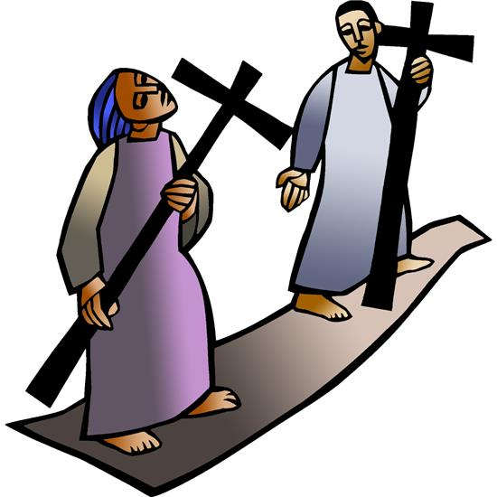

Hymn for the Day
Please unmute your microphone

Assisting Minister: We confess out faith with the words of the Apostle’s Creed

APOSTLES CREED
I believe in God, the Father almighty,
creator of heaven and earth.
I believe in Jesus Christ, God’s only Son, our Lord,
who was conceived by the Holy Spirit,
born of the virgin Mary,
suffered under Pontius Pilate,
was crucified, died, and was buried;
he descended to the dead.*
On the third day he rose again;
he ascended into heaven,
he is seated at the right hand of the Father,
and he will come to judge the living and the dead.
I believe in the Holy Spirit,
the holy catholic church,
the communion of saints,
the forgiveness of sins,
the resurrection of the body,
and the life everlasting. Amen.

PRAYERS OF INTERCESSION
Relying on the promises of God, we pray boldly for the church, the world, and all in need.
A brief silence for meditation and prayer.
Your gift of grace is for all people. Give confident faith to all the baptized, that they may follow you wholeheartedly. Give new believers joy in your promises; give hope and courage to those who suffer for their faith. Lord, In your mercy.
Hear our prayer.
All the ends of the earth worship you. From galaxies to microorganisms, preserve your creation. Teach humanity to wonder at your works and to join you in tending to creation’s well-being. Lord, In your mercy.
Hear our prayer.
You rule over the nations. Raise up advocates for peace and justice within and between nations. Give life where hope seems dead; call into existence new realities we cannot even imagine.
Lord, In your mercy.
Hear our prayer.
In Jesus you joined humanity in suffering and death. Reveal to all the depth of your love shown on the cross. Accompany all who suffer in body, mind, and spirit. Restore all who are sick or grieving. Bring vindication for victims of injustice, exploitation, and oppression (especially). Lord, In your mercy.
Hear our prayer.
You made Abraham and Sarah the ancestors of a multitude of nations. Bless grandparents, parents, and foster parents, and the children who look to them for care and guidance. Console those who deal with infertility, parents who have entrusted their children to adoption, and children longing to be adopted. Equip ministries and services to families.
Lord, In your mercy.
Hear our prayer.
For whom does the people of King of Glory also pray? A time for worshippers to pray for personal needs aloud or in silence.
Lord, in your mercy.
Hear our prayer.
We await the day of Christ’s coming in glory. Lead us by the example of all the saints whom you have called to take up their cross and follow you, that together we may find our lives in you. Lord, In your mercy.
Hear our prayer.
We entrust ourselves and all our prayers to you, O faithful God, through Jesus Christ our Lord.
Amen.

Assisting Minister: The Peace of the Lord be with you always
And also with you

GREAT THANKSGIVING
Pastor: The Lord be with you.
And also with you.

Pastor: Lift up your hearts.
We lift them to the Lord.

Pastor: Let us give thanks to the Lord our God.
It is right to give our thanks and praise.

Pastor Declares Praise for this Day, ending with
“And so, with the angels and archangels and all the company of heaven, we praise your name and join their unending hymn…”
Holy, holy, holy Lord, Lord God of power and might:
Heaven and earth are full of your glory.
Hosanna in the highest.
Blessed is he who comes in the name of the Lord.
Hosanna in the highest.

Pastor: On the night before he died for us,
our Savior Jesus Christ took bread,
and when he had given thanks to you,
he broke it, and gave it to his friends, and said:
"Take, eat: This is my Body which is given for you.
Do this for the remembrance of me."
As supper was ending, Jesus took the cup of wine,
and when he had given thanks,
he gave it to them, and said: "Drink this, all of you:
This is my Blood of the new Covenant,
which is poured out for you and for all for the forgiveness of sins.
Whenever you drink it, do this for the remembrance of me."

Our Father in heaven, hallowed be your Name,
your kingdom come,
your will be done, on earth as in heaven.
Give us today our daily bread.
Forgive us our sins as we forgive those who sin against us.
Save us from the time of trial,
and deliver us from evil.
For the kingdom, the power, and the glory are yours, now and forever. Amen.

Pastor: The Gifts of God for the People of God.
Receive them knowing that Christ died for you.
Receive them with faith and thanksgiving.

The Communion (We eat and drink together)
Pastor: The body of Christ, given for you.
Amen.
Pastor: The blood of Christ, shed for you.
Amen.
The body of our Lord Jesus Christ and his precious blood, keep and preserve you in eternal life.
Amen.
Assisting Minister: Let us pray.
God of steadfast love, at this table you gather your people into one body for the sake of the world. Send us in the power of your Spirit, that our lives bear witness to the love that has made us new in Jesus Christ, our Savior and Lord. Amen

ANNOUNCEMENTS
- During Lent we share readings on Wednesday evenings at 7 PM on Zoom. The Zoom link will be the same as for Sunday mornings. Nancy Dawes will lead next Wednesday.
- Sign up on Facebook. CROP Walk will take place in March as usual, but it will be virtual. I’ll miss walking together, but will walk because people need our support.
- Last chance to get King’s Courier newsletter articles to Walt to be published about March 1st. February is a short month!
- Next Sunday’s worship will be on Zoom at 10:30 AM. See you then.

Sending Song (Sing together)
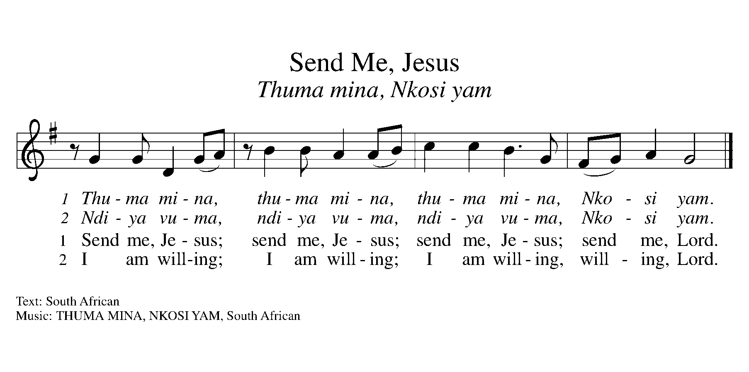
Pastor
You are what God made you to be:
- created in Christ Jesus for good works,
- chosen as holy and beloved,
- freed to serve your neighbor.
God bless you ☩ that you may be a blessing,
in the name of the holy and life-giving Trinity.
Amen

Assisting Minister: Go in peace. Be the light of Christ.
Thanks be to God.

