The Work of the People (The Liturgy)
King of Glory Lutheran Church
Newbury Park, CA
June 20, 2021 4th Sunday after Pentecost
NOTE: The People will read the bold print

Assisting minister: Welcome to Worship at King of Glory. We are excited to see those attending in person, and joyful for those joining us virtually. All are welcomed to this place.
- Please wear your mask unless you are uncomfortable with that. This may be especially important when singing, speaking or coughing. This request is for the protection of the congregation worshiping here as not all are vaccinated.
- For those who are worshipping by Zoom, please secure a piece of bread or a cracker plus some wine or water so we all can share in the Body and Blood of Jesus today.
- Let’s begin:

Now is the acceptable time; now is the day of salvation! Now we are in the storm, the boat almost swamped; but Jesus is here now, and when we call him, he will calm the storm. Even the wind and waves listen to him as they would to their creator. We also listen to him and are called to believe in the power of God’s word in him, a power greater than all that we fear.

CONFESSION AND FORGIVENESS
All may make the sign of the cross, the sign marked at baptism, as the presiding minister begins.
Pastor: Blessed be the holy Trinity,☩ one God, the God of manna, the God of miracles,
the God of mercy.
Amen.
Pastor: Drawn to Christ and seeking God’s abundance, let us confess our sin.
Silence is kept for reflection.
God, our provider, help me. It is hard to believe there is enough to share. I question your ways when they differ from the ways of the world in which we live. I turn to my own understanding rather than trusting in you. I take offense at your teachings and your ways. Turn me again to you. Where else can I turn? Share with me the words of eternal life and feed all of us for life in the world.
Amen.
Pastor: Beloved people of God: in Jesus, the manna from heaven, you are fed and nourished. By Jesus, the worker of miracles, there is always more than enough. Through Jesus, ☩ the bread of life, you are shown God’s mercy: you are forgiven and loved into abundant life.
Amen.
Assisting minister: The grace of our Lord Jesus Christ, the love of God, and the communion of the Holy Spirit be with you all.
And, also with you.
HYMN OF PRAISE:
Eternal Father, Strong to Save Green Hymnal #467

PRAYER OF THE DAY
Assisting Minister: In joy of new life let us pray together.
A brief silence is kept before the prayer.

O God of creation, eternal majesty, you preside over land and sea, sunshine and storm. By your strength pilot me, by your power preserve me, by your wisdom instruct me, and by your hand protect me, through Jesus Christ, our Savior and Lord. Amen.

THE READINGS
First Reading: Job 38:1-11
At the end of the book of Job, after Job and his companions have argued about the cause of the great suffering Job endures, God finally speaks. These verses begin that speech, which is a grand vision of creation, describing God’s ordering of the cosmos and inviting Job to marvel at its beauty.
¹The Lord answered Job out of the whirlwind:
²“Who is this that darkens counsel by words without knowledge?
³Gird up your loins like a man,
I will question you, and you shall declare to me.
⁴“Where were you when I laid the foundation of the earth?
Tell me, if you have understanding.
⁵Who determined its measurements—surely you know!
Or who stretched the line upon it?
⁶On what were its bases sunk,
or who laid its cornerstone
⁷when the morning stars sang together
and all the heavenly beings shouted for joy?
⁸“Or who shut in the sea with doors
when it burst out from the womb?—
⁹when I made the clouds its garment,
and thick darkness its swaddling band,
¹⁰and prescribed bounds for it,
and set bars and doors,
¹¹and said, ‘Thus far shall you come, and no farther,
and here shall your proud waves be stopped’?”

Second Reading: 2 Corinthians 6:1-13
¹As we work together with him, we urge you also not to accept the grace of God in vain. ²For he says,
“At an acceptable time I have listened to you,
and on a day of salvation I have helped you.”
See, now is the acceptable time; see, now is the day of salvation! ³We are putting no obstacle in anyone’s way, so that no fault may be found with our ministry, ⁴but as servants of God we have commended ourselves in every way: through great endurance, in afflictions, hardships, calamities, ⁵beatings, imprisonments, riots, labors, sleepless nights, hunger; ⁶by purity, knowledge, patience, kindness, holiness of spirit, genuine love, ⁷truthful speech, and the power of God; with the weapons of righteousness for the right hand and for the left; ⁸in honor and dishonor, in ill repute and good repute. We are treated as impostors, and yet are true; ⁹as unknown, and yet are well known; as dying, and see—we are alive; as punished, and yet not killed; ¹⁰as sorrowful, yet always rejoicing; as poor, yet making many rich; as having nothing, and yet possessing everything.
¹¹We have spoken frankly to you Corinthians; our heart is wide open to you. ¹²There is no restriction in our affections, but only in yours. ¹³In return—I speak as to children—open wide your hearts also.
The Word of the Lord
Thanks be to God

THE GOSPEL:

GOSPEL ACCLAMATION
Alleluia. Now is the acceptable time; now is the day of salvation. Alleluia. (2 Cor. 6:2)

Pastor: The Holy Gospel according to Mark 4: 35-41
Glory to You O Lord
³⁵When evening had come, [Jesus said to the disciples,] “Let us go across to the other side.” ³⁶And leaving the crowd behind, they took him with them in the boat, just as he was. Other boats were with him. ³⁷A great windstorm arose, and the waves beat into the boat, so that the boat was already being swamped. ³⁸But he was in the stern, asleep on the cushion; and they woke him up and said to him, “Teacher, do you not care that we are perishing?” ³⁹He woke up and rebuked the wind, and said to the sea, “Peace! Be still!” Then the wind ceased, and there was a dead calm. ⁴⁰He said to them, “Why are you afraid? Have you still no faith?” ⁴¹And they were filled with great awe and said to one another, “Who then is this, that even the wind and the sea obey him?”
The Gospel of the Lord.
Thanks be to God
SERMON: PASTOR DON KOEPKE

Silence for Reflection
HYMN OF THE DAY
Go My Children Blue Hymnal # 721

Assisting minister: Please join me in professing your faith to each other by means of the
APOSTLES CREED

I believe in God, the Father almighty,
creator of heaven and earth.
I believe in Jesus Christ, God’s only Son, our Lord,
who was conceived by the Holy Spirit,
born of the virgin Mary,
suffered under Pontius Pilate,
was crucified, died, and was buried;
he descended to the dead.*
On the third day he rose again;
he ascended into heaven,
he is seated at the right hand of the Father,
and he will come to judge the living and the dead.
I believe in the Holy Spirit,
the holy catholic church,
the communion of saints,
the forgiveness of sins,
the resurrection of the body,
and the life everlasting. Amen.

PRAYERS OF INTERCESSION
Assisting minister: Let us come before the triune God in prayer.
A brief silence.
Holy God, you gather your people from east and west, north and south. We pray for the mission of the church throughout the world, that your steadfast love may be made known to all peoples. Lord, in your mercy,
hear our prayer.
You laid the foundations of the earth and the waters are the womb of creation. The morning stars sing your name and all creation shouts for joy. We pray for your blessed creation, that it may continue to flourish and magnify your glory. Lord, in your mercy,
hear our prayer.
You keep watch over all nations. We pray for countries experiencing violence, hunger, and unrest (especially). Guide worldwide and local community organizations in their efforts to establish safety and justice. Lord, in your mercy,
hear our prayer.
You are close to the brokenhearted and near to those in distress. We pray for those who are experiencing oppression. Liberate us from the systems and chains that bind us. Remove the barriers that separate us from one another. Lord, in your mercy,
hear our prayer.
You dwell with us in this faith community. We pray for our leaders and elders (especially). Grant them knowledge, patience, and kindness, that through their leadership you may be exalted in this assembly. Lord, in your mercy,
hear our prayer.
Here other intercessions may be offered.
Your love endures in all situations. On this Father’s Day, we pray for those who are fathers or wish to be fathers, for those with broken or strained relationships, for those who are missing their fathers, and for fathers who have lost children. Bless and strengthen them. Lord, in your mercy,
hear our prayer.
What else do the people of God pray for silently in their hearts or aloud?
We pause here for individual prayer. Lord, in your mercy
Hear our prayer.
We lift our prayers to you, O God, trusting in your abiding grace.
Amen.

Pastor: The Peace of the Lord be with you always
And also with you
OFFERTORY PRAYER
Assisting minister: Let us pray.
Merciful Father, we offer with joy and thanksgiving what you have first given us—our selves, our time, and our possessions, signs of your gracious love. Receive them for the sake of him who offered himself for us, Jesus Christ our Lord. Amen

GREAT THANKSGIVING

Pastor: Christ has set the table with more than enough for all. Come!
Pastor: The Lord be with you.
And also with you.
Pastor: Lift up your hearts.
We lift them to the Lord.
Pastor: Let us give thanks to the Lord our God.
It is right to give our thanks and praise.

Pastor Declares Praise for this Day, which ends with the words
“…with angels and archangels, and with all in heaven, we praise your name and join their unending hymn”
Holy, holy, holy Lord, Lord God of power and might:
Heaven and earth are full of your glory.
Hosanna in the highest.
Blessed is he who comes in the name of the Lord.
Hosanna in the highest.

Pastor: On the night before he died for us,
our Savior Jesus Christ took bread,
and when he had given thanks to you,
he broke it, and gave it to his friends, and said:
"Take, eat: This is my Body which is given for you.
Do this for the remembrance of me."
As supper was ending, Jesus took the cup of wine,
and when he had given thanks,
he gave it to them, and said: "Drink this, all of you:
This is my Blood of the new Covenant,
which is poured out for you and for all for the forgiveness of sins.
Whenever you drink it, do this for the remembrance of me."

Lord, remember us in your Kingdom and teach us to pray:

Our Father in heaven, hallowed be your Name,
your kingdom come,
your will be done, on earth as in heaven.
Give us today our daily bread.
Forgive us our sins as we forgive those who sin against us.
Save us from the time of trial,
and deliver us from evil.
For the kingdom, the power, and the glory are yours, now and forever. Amen.

Pastor: The Gifts of God for the People of God.
Receive them knowing that Christ died for you.
Receive them with faith and thanksgiving.

We Commune with Jesus (We eat and drink together)
Pastor: The body of Christ, given for you.
Amen.
Pastor: The blood of Christ, shed for you.
Amen.
Assisting Minister: Let us pray,
Jesus, Bread of life, we have received from your table more than we could ever ask. As you have nourished us in this meal, now strengthen us to love the world with your own life. In your name we pray.
Amen

Assisting minister: ANNOUNCEMENTS
- The King of Glory Worship next Sunday, and ongoing will continue to be in-person worship in the sanctuary at King of Glory. AND we also plan to have the worship on Zoom, however note the time will be at 9:30.
- On Saturday June 19 King of Glory again prepared 50 Dinners for the Hungry. Thank you to all who prepared food for this ministry.
- There will be special treats on the patio along with coffee. Please join us!
- Flowers provided by Debby and Ed Carloni in memorial to Ed's friend Don Neumann.
- Does anyone else have an announcement to share?

SENDING SONG (SING TOGETHER)
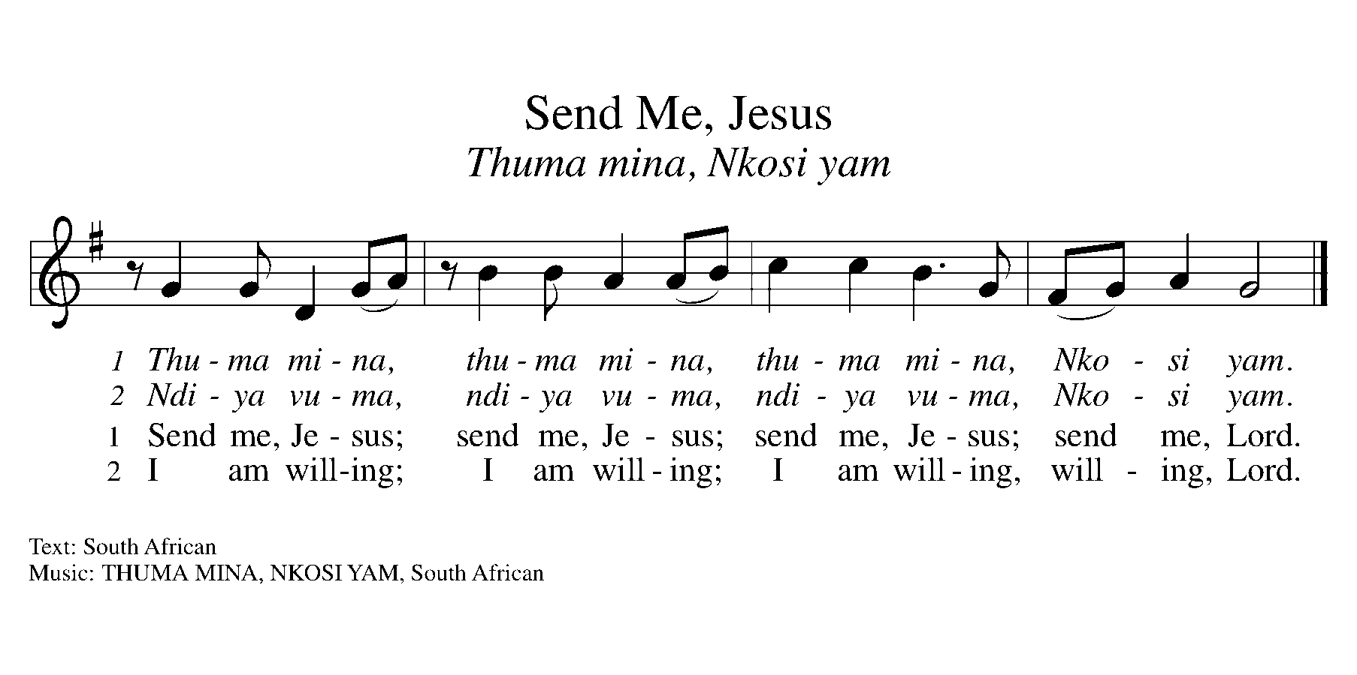

BLESSING
Pastor: The blessing of God, who provides for us, feeds us, and journeys with us, ☩ be upon you now and forever.
Amen.

DISMISSAL
Pastor: Go in peace. You are the body of Christ.
Thanks be to God.

