The Work of the People (The Liturgy)
King of Glory Lutheran Church
Newbury Park, CA
Sunday, May 16, 2021 – The 7th Sunday of Easter
NOTE: The People will read the bold print

Assisting Minister: Welcome to Worship at King of Glory
- We will be communing with Jesus today so you are invited to secure a piece of bread and some wine so that you might receive the Body and Blood of our Savior.
- We will be unmuted during any response and prayer. It will be impossible to stay completely together but God hears through the confusion and we need to sense our community in Christ that comes as we worship Jesus.
- Let’s begin:
- Introduction: The gospel for Easter’s seventh Sunday is always taken from the long prayer Jesus prays for his followers in John’s gospel on the night before his death, and always includes Jesus’ desire that his followers will be one as he and the Father are one. This oneness is not mere doctrinal agreement or institutional unity, but mutual abiding, interpenetrating life, mutual love, and joy. This oneness is the work of the Spirit whom we have received but also await. Come, Holy Spirit!

THANKSGIVING FOR BAPTISM
Pastor: Alleluia! Christ is risen.
Christ is risen indeed. Alleluia!
Pastor: Refreshed by the resurrection life we share in Christ,
let us give thanks for the gift of baptism when God, by grace, made us a new creation.
Water may be poured into the font as we give thanks.
I thank you, risen Christ, for these waters where you make me new, leading me from death to life, from tears to joy. I bless you, risen Christ, that your Spirit comes to me and to all people in the grace-filled waters of rebirth, like rains to the thirsting earth, like streams that revive my soul, like cups of cool water shared with strangers. Breathe your peace on me when I hide in fear. Clothe me with your mercy and forgiveness. Send all people companions on our journey as we share your life.
Make King of Glory one people in you, risen Christ.
Cleanse our hearts.
Shower us with life.
To you be given all praise, with the Holy Spirit, in the glory of God, now and forever.
Amen.

Assisting Minister: The grace of our Lord Jesus Christ, the love of God, and the communion of the Holy Spirit be with you all.
And, also with you.
Please Mute your microphone
HYMN OF PRAISE:
Please Unmute your microphone

PRAYER OF THE DAY
Assisting Minister: In joy of new life let us pray together.
A brief silence is kept before the prayer.

Gracious and glorious God, you have chosen us as your own, and by the powerful name of Christ you protect us from evil. By your Spirit transform us and your beloved world, that we may find our joy in your Son, Jesus Christ, our Savior and Lord, who lives and reigns with you and the Holy Spirit, one God, now and forever. Amen.

THE READINGS
First Reading: Acts 1:15-17, 21-26
In the days between Jesus’ ascension and Pentecost, Peter oversees the process whereby one of the members of the community of believers is chosen to be the twelfth apostle, in order to fill the vacancy created by Judas’s treachery and death.
¹⁵In those days Peter stood up among the believers (together the crowd numbered about one hundred twenty persons) and said, ¹⁶“Friends, the scripture had to be fulfilled, which the Holy Spirit through David foretold concerning Judas, who became a guide for those who arrested Jesus—¹⁷for he was numbered among us and was allotted his share in this ministry.” ²¹So one of the men who have accompanied us during all the time that the Lord Jesus went in and out among us, ²²beginning from the baptism of John until the day when he was taken up from us—one of these must become a witness with us to his resurrection.” ²³So they proposed two, Joseph called Barsabbas, who was also known as Justus, and Matthias. ²⁴Then they prayed and said, “Lord, you know everyone’s heart. Show us which one of these two you have chosen ²⁵to take the place in this ministry and apostleship from which Judas turned aside to go to his own place.” ²⁶And they cast lots for them, and the lot fell on Matthias; and he was added to the eleven apostles.
Second Reading: 1 John 5:9-13
God has borne witness to the gift of eternal life in Jesus Christ. Whoever believes in the Son of God believes in the witness of God and has the promise of eternal life.
⁹If we receive human testimony, the testimony of God is greater; for this is the testimony of God that he has testified to his Son. ¹⁰Those who believe in the Son of God have the testimony in their hearts. Those who do not believe in God have made him a liar by not believing in the testimony that God has given concerning his Son. ¹¹And this is the testimony: God gave us eternal life, and this life is in his Son. ¹²Whoever has the Son has life; whoever does not have the Son of God does not have life.
¹³I write these things to you who believe in the name of the Son of God, so that you may know that you have eternal life.
The Word of the Lord
Thanks be to God

THE GOSPEL:

GOSPEL ACCLAMATION
Alleluia. I will not leave you orphaned, says the Lord. I am coming to you. Alleluia.
(John 14:18)

Pastor: The Holy Gospel according to John 17:6-19
Glory to You O Lord
[Jesus prayed:] ⁶“I have made your name known to those whom you gave me from the world. They were yours, and you gave them to me, and they have kept your word. ⁷Now they know that everything you have given me is from you; ⁸for the words that you gave to me I have given to them, and they have received them and know in truth that I came from you; and they have believed that you sent me. ⁹I am asking on their behalf; I am not asking on behalf of the world, but on behalf of those whom you gave me, because they are yours. ¹⁰All mine are yours, and yours are mine; and I have been glorified in them. ¹¹And now I am no longer in the world, but they are in the world, and I am coming to you. Holy Father, protect them in your name that you have given me, so that they may be one, as we are one. ¹²While I was with them, I protected them in your name that you have given me. I guarded them, and not one of them was lost except the one destined to be lost, so that the scripture might be fulfilled. ¹³But now I am coming to you, and I speak these things in the world so that they may have my joy made complete in themselves. ¹⁴I have given them your word, and the world has hated them because they do not belong to the world, just as I do not belong to the world. ¹⁵I am not asking you to take them out of the world, but I ask you to protect them from the evil one. ¹⁶They do not belong to the world, just as I do not belong to the world. ¹⁷Sanctify them in the truth; your word is truth. ¹⁸As you have sent me into the world, so I have sent them into the world. ¹⁹And for their sakes I sanctify myself, so that they also may be sanctified in truth.”
The Gospel of the Lord.
Thanks be to God

Please mute your microphone
SERMON: PASTOR DON KOEPKE
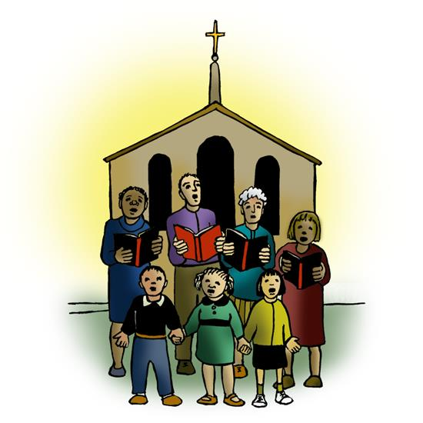
Silence for Reflection

HYMN OF THE DAY

Please unmute your microphone

Assisting Minister: Please join me in professing your faith to each other by means of the
APOSTLES CREED

I believe in God, the Father almighty,
creator of heaven and earth.
I believe in Jesus Christ, God’s only Son, our Lord,
who was conceived by the Holy Spirit,
born of the virgin Mary,
suffered under Pontius Pilate,
was crucified, died, and was buried;
he descended to the dead.*
On the third day he rose again;
he ascended into heaven,
he is seated at the right hand of the Father,
and he will come to judge the living and the dead.
I believe in the Holy Spirit,
the holy catholic church,
the communion of saints,
the forgiveness of sins,
the resurrection of the body,
and the life everlasting. Amen.

PRAYERS OF INTERCESSION
You are alive in the risen Christ by the power of the Holy Spirit so we bring our prayers before God who promises to hear us and answer in steadfast love.
A brief silence.
Holy God, in Christ Jesus the joy of the church is made complete. Root the church in your Word and unify us as Christ’s body. Send us into the world as your loving people, ready to testify to your Spirit at work. Lord, in your mercy.
Hear our prayer.
Mighty God, the world is your handiwork, displaying your creative impulse. Seas teem with life, forests reach up to praise you, and the mystery of life lies deep in the soil. Guard and keep this world for the well-being of all your creatures. Lord, in your mercy.
Hear our prayer.
Gracious Sovereign, those who follow your ways are like trees planted near streams of water. Establish the leaders of nations and all in authority in your grace and truth. Strengthen them, so that the people they serve will have abundant life. Lord, in your mercy.
Hear our prayer.
Generous Savior, you befriend those who are sick, suffering, poor, lonely, outcast, rejected, or sick. Grant healing and love to all in need. Give them tangible signs of your steadfast love. Lord, in your mercy.
Hear our prayer.
Creator God, here in this community we share the gift of praying, learning, and supporting one another. Give us thankful hearts as we claim the gifts that are unique to us and keep us from being envious of others with different gifts. Lord, in your mercy.
Hear our prayer.
Saving God, your wonderful promise is the gift of eternal life in Jesus. Through the witness of those who have died in you, strengthen us now in this gift of life. We cherish the memory of your saints. Lord, in your mercy.
Hear our prayer.
What else do the people of God pray for silently in their hearts or aloud?
We pause here for individual prayer. Lord, in your mercy
Hear our prayer.
In the hope of new life in Christ, we raise our prayers to you, trusting in your never-ending goodness and mercy; through Jesus Christ our Lord.
Amen.

Assisting Minister: The Peace of the Lord be with you always
And also with you

GREAT THANKSGIVING
Pastor: The Lord be with you.
And also with you.

Pastor: Lift up your hearts.
We lift them to the Lord.

Pastor: Let us give thanks to the Lord our God.
It is right to give our thanks and praise.

Pastor Declares Praise for this Day, which ends with the words
“…with angels and archangels, and with all in heaven, we praise your name and join their unending hymn”
Holy, holy, holy Lord, Lord God of power and might:
Heaven and earth are full of your glory.
Hosanna in the highest.
Blessed is he who comes in the name of the Lord.
Hosanna in the highest.

Pastor: On the night before he died for us,
our Savior Jesus Christ took bread,
and when he had given thanks to you,
he broke it, and gave it to his friends, and said:
"Take, eat: This is my Body which is given for you.
Do this for the remembrance of me."
As supper was ending, Jesus took the cup of wine,
and when he had given thanks,
he gave it to them, and said: "Drink this, all of you:
This is my Blood of the new Covenant,
which is poured out for you and for all for the forgiveness of sins.
Whenever you drink it, do this for the remembrance of me."

Lord, remember us in your Kingdom and teach us to pray:

Our Father in heaven, hallowed be your Name,
your kingdom come,
your will be done, on earth as in heaven.
Give us today our daily bread.
Forgive us our sins as we forgive those who sin against us.
Save us from the time of trial,
and deliver us from evil.
For the kingdom, the power, and the glory are yours, now and forever. Amen.

Pastor: The Gifts of God for the People of God.
Receive them knowing that Christ died for you.
Receive them with faith and thanksgiving.

We Commune with Jesus (We eat and drink together)
Pastor: The body of Christ, given for you.
Amen.
Pastor: The blood of Christ, shed for you.
Amen.
Minister: Let us pray.
Wellspring of joy, through this meal you have put gladness in my heart. Satisfy the hunger still around us all, and send me as a joyful witness, that your love may bring joy to the hearts of all people, through Jesus Christ our Lord. Amen

Assisting Minister: ANNOUNCEMENTS
- King of Glory provided the Dinner for the Hungry on Saturday May 15. Thank you to everyone that supported this ministry with gifts of food and effort.
- The King’s Readers Book Club will meet via Zoom on Wednesday May 19 at 10 AM.
- The KOG Council and the Preschool Board will meet via Zoom this Thursday.
- The Cubero’s will be heading to Indiana, and we will miss them so much. Please join in a farewell picnic on May 23, next Sunday, at Old Meadow Park in T. O. Complete information is in the newsletter.
- Does anyone else have an announcement to share?

Sending Song (Sing together)
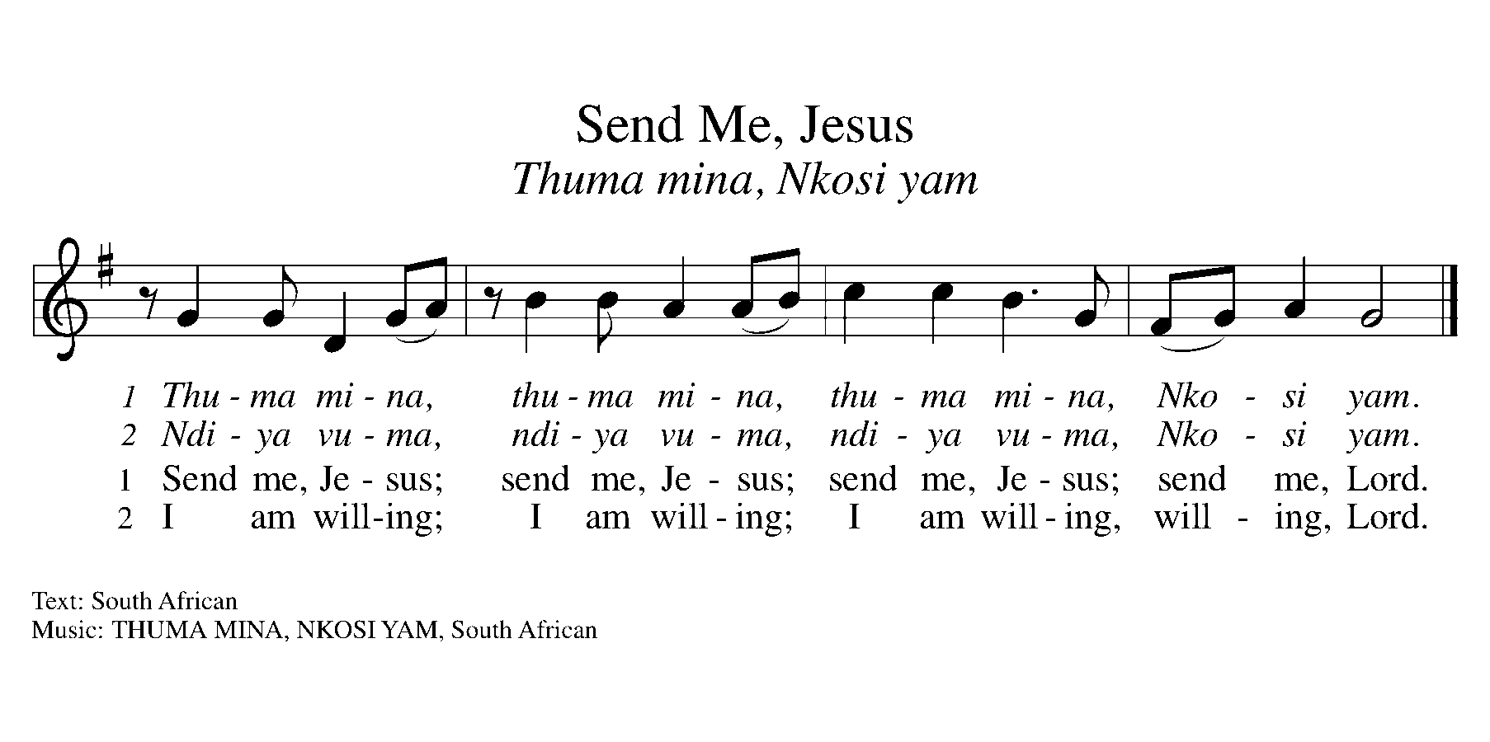

BLESSING
Pastor: We give thanks that today our glorious God has granted you a spirit of wisdom to know and to love the risen Lord Jesus. The God of life, Father, ☩ Son, and Holy Spirit, bless you now and forever.
Amen.

DISMISSAL
Pastor: Alleluia! Christ is risen.
Christ is risen indeed. Alleluia!
Go in peace. Share the good news. Alleluia!
Thanks be to God. Alleluia!

